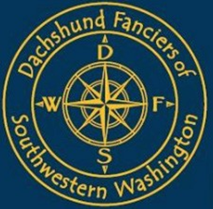

There are 41 dogs entered in this Specialty Show with a total entry of 44 in 3 different Varieties. For your convenience, the following division of sexes has been carefully tabulated, however, neither the Club nor the Show Secretary assumes responsibility for absolute accuracy.
Dachshund Fanciers of Southwestern Washington
Friday December 2, 2022 Puppy Sweepstakes 1:00P.M.

Ring 14: 1:00 PM Judge: Mrs. Meta Hyder
Puppy Sweepstakes (3)
1 – Longhaired (1-0)
1 – Smooths (1-0)
1 – Wirehaired (0-1)

Dachshund Fanciers of Southwestern Washington
Friday December 2, 2022 Regular Classes 1:15P.M.

Ring 14: 1:15 PM Judge: Ms. Emily Fish
Regular Classes (41)
15 - Longhaired 3-8-(3-1)
9 - Smooths 1-2-(2-4)
17 - Wirehaired 5-6-(3-3)
To Be Followed By Inter-Variety Competition
Best of Breed
Best of Opposite Sex to Best of Breed

Clark County Event Center 17402 NE Delfel Road, Ridgefield, WA 98642
This Specialty is being held concurrently with the Greater Clark County Kennel Club, Inc., All-Breed Show.
ALL RINGS WILL BE IN THE EVENT CENTER

HOLIDAY FESTIVE ATTIRE IS ENCOURAGED!

